**P.3 LITERACYIA LESSON NOTES TERM II 2020**

**Week I**

**LESSON 1**

**CONTENT: Living things**

Living things are things which have life.

**Examples of living things**

* plants
* birds
* fish
* insects
* man
* dogs
* giraffes

**Characteristics of living things**

* All living things feed
* All living things move
* All living things respire
* All living things grow
* They all reproduce
* They respond to stimuli

**Groups of living things**

* animals
* plants

**Mixed activity**

1. What are living things?
2. Identify any four examples of living things
3. Why are plants called living things?
4. State any four characteristics of living things
5. A part form plants, name any other group of living things

**LESSON 2**

**CONTENT: Uses of animals**

* Some animals are eaten by people e.g. cows, goats, sheep, camel etc.
* Some animals are sold to get money.
* Cats eat rats and mice in our homes
* Some animals provide skin and hides e.g. cows, goats, sheep, camels etc.
* Some animals are used for transport e.g. donkey, horses, camels.
* Dogs provide security at home
* Sheep provide us with wool and mutton .
* Animal dung is used to make manure.
* Oxen are used for ploughing

**Examples of animal products**

* skins
* dung
* urine
* blood
* wool
* fur
* milk
* meat

**Things made from skin and hides**

* Drums
* Bag wallets
* Bags
* Belts
* Shoes

**Exercise**

1. Mention any three things made out of wool.
2. Why do we keep cats at home?
3. Identify the domestic animal kept for security.
4. Give any two aquatic animals
5. Give the habitats of following animals

Lion __________ squirrels __________ zebra __________

**LESSON 3**

**CONTENT: Caring for animals**

* Feeding them
* Building shelter for animals
* Treating animals
* Putting wild animals in game parks.
* Spraying with chemicals.
* Avoid destroying swamps and forests.

**Birds and insects**

**Characteristics of birds**

* Birds lay eggs.
* Birds bodies are covered with feathers,
* Birds have wings
* They have beaks

**Exercise**

1. How useful are feathers to birds?
2. How do the following animals move?

Frogs ___________

Fish ____________

Snakes ____________

1. What do birds use to breathe?
2. Identify any three ways how people can care for animals
3. In one sentence give the meaning of animal habitat.

**LESSON 4**

**CONTENT: Types of birds**

* Domestic birds
* Wild birds

**Domestic birds**

* Domestic birds are birds tamed by people .

**Examples of domestic birds**

* Turkeys
* Pigeons
* Chicken
* Ducks
* Guinea fowls
* Parrots

**Wild birds**

Wild birds are birds that live in the bush or forest.

**Examples of wild birds**

* Crested crane
* Crows
* Ostrich
* Vultures
* Weaver birds
* Marabou stork
* sun birds
* eagles
* kites
* penguin, kiwi, ostrich } flightless birds

**Exercise**

1. What is the difference between wild birds and domestic birds?
2. Why do people in your community keep birds like hens?
3. State any four examples of domestic birds
4. What are wild animals?
5. Identify any four examples of wild birds

**Week 2**

**LESSON 1**

**CONTENT: Habitats of birds**

* A habitat is a home of a living thing.
* Habitat of birds are homes of birds

**Examples of habitats for birds**

* Domestic birds live in cages while wild birds live in nests.

**Common places where birds are found**

* swamps
* gardens
* sanctuaries
* water
* forests

**Uses of birds**

* Birds provide meat e.g. turkey, chicken, doves etc.
* Feathers are used for decoration e.g in suits, hats.
* Birds bones’ are used for making glue.
* Birds are sold to get money.
* Some birds are used for paying bride price
* Birds provide us with eggs

**Uses of feathers**

* For decoration
* For making pillows

**Exercise**

1. State one use of birds to plants
2. Name three birds eaten by people.
3. How useful are birds to people?
4. How are feathers useful to people?
5. How can a P.3 boy protect water sources?

**LESSON 2**

**CONTENT: Caring for birds**

* Providing shelter
* Feeding birds
* Cleaning their habitats
* Treating birds

**INSECTS**

**Examples of insects**

* White ants
* Black ants
* Tsetse flies
* Wasps
* Houseflies
* Termites
* Mosquitoes
* Bees
* Locusts
* Butterflies
* Cockroaches

**Parts of an insect**

A

B

C

D

E

I F

H G

1. Feelers
2. Compound eyes
3. Legs
4. Thorax
5. Wings
6. Spiracles
7. Ovipositor
8. Halteres

**Uses of parts of an insect**

**Feelers -** used for feeling

**Spiracles -** used for breathing

**Wings -** used for flying

**Ovipositors -** used for laying eggs.

* + - Used for mating
    - Used for protection in bees and wasps
* **Halteres -** For balancing when flying

**Exercise**

1. Write two examples of insects
2. Draw an insect and name the
3. Spiracles - ovipositor
4. On which part of an insect are the legs attached?
5. How are the halters useful on an insect?
6. Why should we brush our teeth after every meal?
7. In one sentence give the meaning of soil profile.

**LESSON 3**

**CONTENT: Characteristics of insects**

* An insect has three main body divisions i.e. head, thorax, abdomen.
* An insect uses spiracles for breathing.
* An insect has three pairs of legs or six legs.

**Reproduction of insects**

**Insects reproduce by laying eggs**

**Harmful insects**

* Bees
* Mosquitoes
* Wasps
* Termites
* Black ants
* Tsetse flies
* Butterflies
* Moths
* houseflies

**Useful insects**

* White ants
* Grasshopper
* Bees

**Insects which have wings**

* locusts
* cockroaches
* butterflies
* bees
* houseflies
* crickets

**Insects without wings**

* Termites
* Black ants
* Red ants

**Qn : Why is a spider not grouped under insects**

* It has two main body divisions i.e. cephalo thorax and abdomen while an insect has three main body divisions.
* It has eight legs while an insect has six legs
* It uses book lungs for breathing while an insect uses spiracles for breathing.

**Exercise**

1. Write two examples of insects which sting.
2. How many legs has an insect?
3. Give any two characteristics of insects.
4. Why is a spider not called an insect?
5. Name any four insects with wings
6. How do insects reproduce?

**LESSON 4**

**CONTENT: Types of insects**

* Social insects
* Solitary insects

**Social insects**

These are insects which move, live and work together.

**Examples of social insects**

* Honey bees
* Black ants
* Wasps
* Termites
* Red ants or safari ants
* sugar ants
* soldier ants

**Characteristics of social insects**

* They live together with others
* They move together with others
* They work together with others

**Solitary insects**

Solitary insects are insects which live, move and work alone.

**Examples of solitary insects**

* Mosquitoes
* Tsetse flies
* Butter flies
* Fleas
* Cockroaches
* Grasshoppers
* Houseflies
* Crickets
* Bed bugs

**Characteristics of solitary insects**

* They live alone
* They work alone
* They move alone

**Exercise**

1. Why is a spider not called an insect?
2. Give two characteristics of solitary insects.
3. What is the difference between social and solitary insects?
4. State any four examples of solitary insects

**Week 3**

**LESSON 1**

**CONTENT: Uses of insect**

* Some insects are eaten as food e.g. white ants, grasshoppers and locusts.
* Bees provide us with honey and wax.
* Some insects pollinate crops e.g. bees, moths and butterflies

**Uses of honey**

* Honey sweetens bread.
* Honey is used as food.
* Honey is used as medicine

**Things made out of bee wax**

* Candle wax
* Cosmetics
* Shoe Polish
* Match sticks

**Dangers of insects**

* Many insects spread diseases e.g. house flies, mosquitoes, tsetse flies.
* Some insects destroy crops e.g. termites, grasshoppers and locusts.
* Some insects destroy furniture and house hold property e.g. cockroaches, wood lice
* Some insects destroy animal habitats e.g. red ants, black ants

**Exercise**

1. Write two insects eaten by people
2. Identify two products got from bees.
3. How does a wasp protect itself?
4. How is honey useful to people?
5. Identify any two products got from bee wax
6. State any two dangers of insects to people

**LESSON 2**

**CONTENT: Insect habitat**

* Insect habitats are homes of insects

**Examples of insect habitats**

* Anti hills
* Water
* Leaves
* Hives

**Insect which live in (anti- hills)**

* White ants
* Termites

**insects which live on leaves**

Butterflies

Tsetse flies

Mosquitoes

**Hives**

Bees

**NB: Examples of bees**

* Queen bees - female bees in the hive - They lay eggs
* Worker bees – female sterile bees in the hive – Collect nectar

- Clean the hive

- Feed the queen bee

- Protect the hive

* Drone bees – male bees in the hive – mates with the queen bee

**Exercise**

1. What are insect habitats?
2. Name any three insect habitat
3. Identify any two insects which live on leaves
4. State any two types of bees
5. Underline the odd man out

locust termite fleas wasps

floods thunder brick making lightening

**LESSON 3**

**CONTENT: Parts of a fish**

***Pectoralfin***

 eye scales Dorsal fin

nostril

> tail fin/ caudal

mouth

***Gill cover pelvic fin ventral(anal)fin***

lateral line

* Mouth : For picking in food and water
* Nostril : For tasting food
  + - For smelling food
* Eye : for seeing
* Gill cover : protects gills
* Gills : for breathing
* Lateral line : for sensing sound waves in water
* Tail fin : for moving forward and changing direction
* Dorsal : - For protection.

- For rolling in water

* Ventral fins: - For protection.
* Pectoral fin - For stopping movement
* Pelvic fins: For up ward movement in water
* Scales – protects the body from injury.

**Exercise**

1. Which part of a fish is used for swimming backwards?
2. What is the function of gills to a fish?
3. How do we call a glass container used to keep fish and other aquatic animals.

**LESSON 4**

**CONTENT: Characteristics of fish**

* Fish use gills for breathing
* Fish produce by laying eggs.
* They have fins

**Uses of fish to man**

* Fish is used as food by man (source of protein)
* Bones of fish are used for making glue.
* Fish is sold to get money.
* Fish control malaria by eating mosquito larvae in ponds

**Examples of common fish**

* silver cyprinid
* mud fish
* tilapia
* salmon
* cat fish
* Nile perch
* lung fish

**Mixed activity**

1. How do fish reproduce?
2. Name any one common type of fish caught in your community.
3. Which food value do we get from eating fish?
4. Identify any four examples of fish caught in Uganda
5. How is fish useful to people?
6. Draw one item used to clean our body.

**Week 4**

**LESSON 1**

**CONTENT: Fish habitat**

* Fish live in water
* We can keep fish in ponds and aquariums.

**NB:**  A pond is a man made pool of water.

An aquarium is a glass container where fish and other aquatic animals are kept

**Examples of animals found in ponds**

* fish
* frogs
* crabs
* crocodile
* turtles

**NB:** A young fish is called a fry

**Care for fish**

* Provide food for fish
* Protect their eggs from animals and birds
* Feeding the fries in pond.
* Cleaning water sources by removing water weeds and hyacinth

**Exercise**

1. What name is given to young fish?
2. Give the meaning of the word “**pond”**
3. How can we care for fish?
4. State any three examples of animals found in ponds

**Living things (animals )**

**Word bank**

stimuli

reproduce

manure

chemicals

tamed

flightless

habitat

sanctuaries

ovipositor

antenna

divisions

medicine

cosmetics

spread

diseases

sterite

nectar

nostril

injury

aquatic

aquarium

**LESSON 2**

**CONTENT: Examples of plants**

* maize plant
* bean plant
* rice plant
* mosses plant
* sugar plant
* egg plant
* ferns
* lichens

**Groups of plants**

* Non – flowering plants
* Flowering plants

**Non – flowering plants**

These are plants which do not bear flowers

**Examples of non – flowering plants**

* algae
* liver worts
* mosses
* lichens
* ferns
* pines
* cedar soft wood trees/ conifers
* cypress

**NB:** They reproduce by means of spores

Conifers reproduce by means of seeds

**Exercise**

1. Mention any two examples of plants you know.
2. What are non – flowering plants?
3. How do most non – flowering plants reproduce?
4. state one importance of conifers to people
5. How do conifers reproduce?

**LESSON 3**

**CONTENT: Flowering plants**

* Flowering plants are plants that bear flowers

**NB:** They reproduce by means of seeds.

* Root cap protects the growing tip of a root from damage.
* Root hairs absorb water and mineral salts form the soil.

**Examples of flowering plants**

* bean plant
* ground nut plant
* mango plant
* coconut plant
* maize plant
* rice plant
* coffee plant
* orange plant

**Parts of a flowering plant**

Leaf

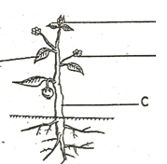

Flower

fruit

stem

Tap root

roots

**Characteristics of plants**

1. Make their own food.
2. Have chlorophyll

**LESSON 4**

**CONTENT: Leaves**

* Leaves grow from stems of a plant
* Leaves are supported by a leaf stalk on a plant

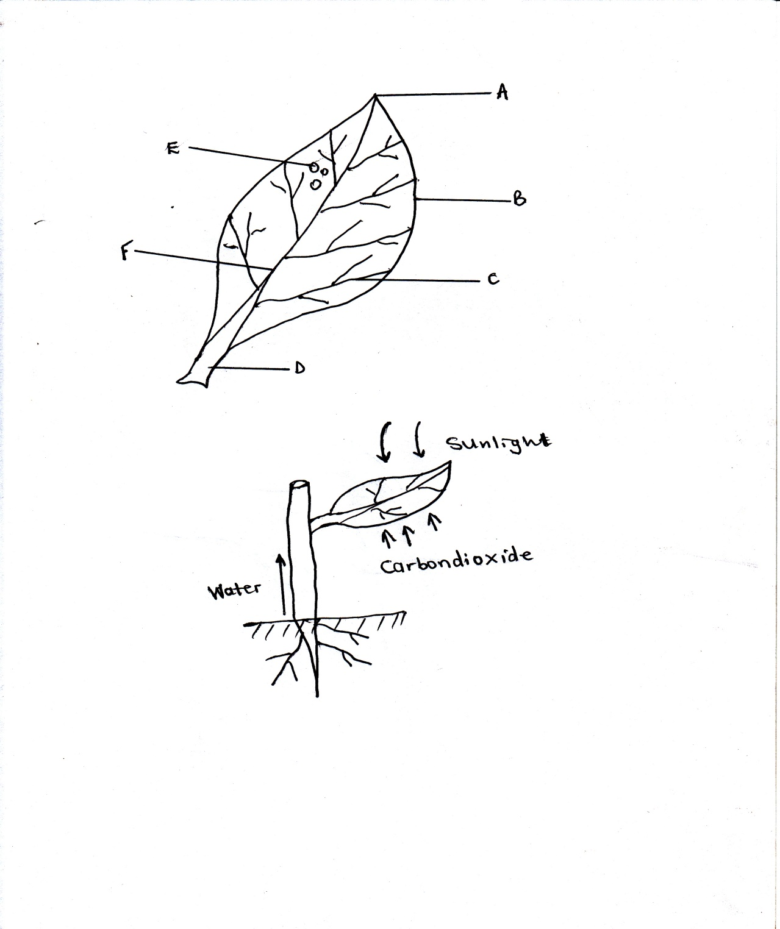**Parts of a leaf**

stomata

**Midrib**

leaf base

Apex

leaf stalk

leaf margin

veins

Lamina / leaf blade

**Note:**

stomata: **Many**

stoma **- one**

**Uses of each part of a leaf**

* Stomata : used for breathing
* Leaf stalk : Holds a leaf on a plant stem
* Vein: Transports water and mineral salts in all parts of a leaf.
* Midrib : Transports water and mineral salts from the stem to the veins.

**Exercise**

1. How important are stomata to a plant?
2. Name the green colouring pigment found in plants
3. State the use of the above mentioned pigment to plants
4. Give one main use of leaves to plants.
5. Write down three uses of leaves to people

**LESSON1**

**CONTENT: Uses of leaves to people**

* Many leaves are eaten as food e.g. cabbages, lettuce, pig weeds (dodo), spinach.
* Some leaves are used as herbal medicine e.g. Mululuza – malaria.
* Some leaves are used for thatching houses e.g. spear grass and papyrus

**Uses of leaves to plants**

* Leaves make food for plants (main use)
* Some leaves store food for plants e.g. Lettuce, cabbage, sukuma wiki.
* Leaves have stomata’s used for breathing
* Leaves carry out transpiration.

**NB:** The main use of leaves to plants is to make food for plants.

**LESSON 2**

**CONTENT: PHOTOSYNTHESIS**

* Photosynthesis is a process by which plants make their own food.
* **Photo –** light
* **Synthesis –**manufacture

**Raw materials for photosynthesis**

* Carbon dioxide
* Water They are used as raw materials

**Conditions for photosynthesis**

* Chlorophyll – for trapping sunlight
* Sun light energy – provide heat energy

**Product of photosynthesis**

* Starch (food)
* Oxygen ( waste product / by product )

**Gas given out by plants at night**

Carbon dioxide

**Gas taken in by plants at night**

* Oxygen

**Food made during photosynthesis**

* Starch

**Exercise**

**LESSON 3**

**CONTENT: STEMS**

**Types of stems**

* Upright stems
* Under ground stems (storage stems)
* Climbing stems
* Creeping stem/ runners

**Examples of plants that store food in stems**

* White yams
* Irish potatoes

**Uses of stems to plants**

* Stems transport water and mineral salts from roots to leaves.
* Some stems store food for plants e.g. Irish potatoes, white yams.(stem tubers)
* Stems transport food made by leaves to roots.

**Uses of stems to people**

* Some stems are used as food e.g. sugar canes.
* Some stems are used as local medicine.
* Some stems are used as fire wood.
* Hard woody stems are used as timber.
* Soft woody stems are used for making ply wood and paper.
* Some stems are used for building houses.

**LESSON 4**

**CONTENT: ROOTS**

* A root is part of a plant which grow in the soil.

**Types of root system**

* Tap root system
* Fibrous root system

**Tap root system**

Tap root system is the system of roots with the main root growing.

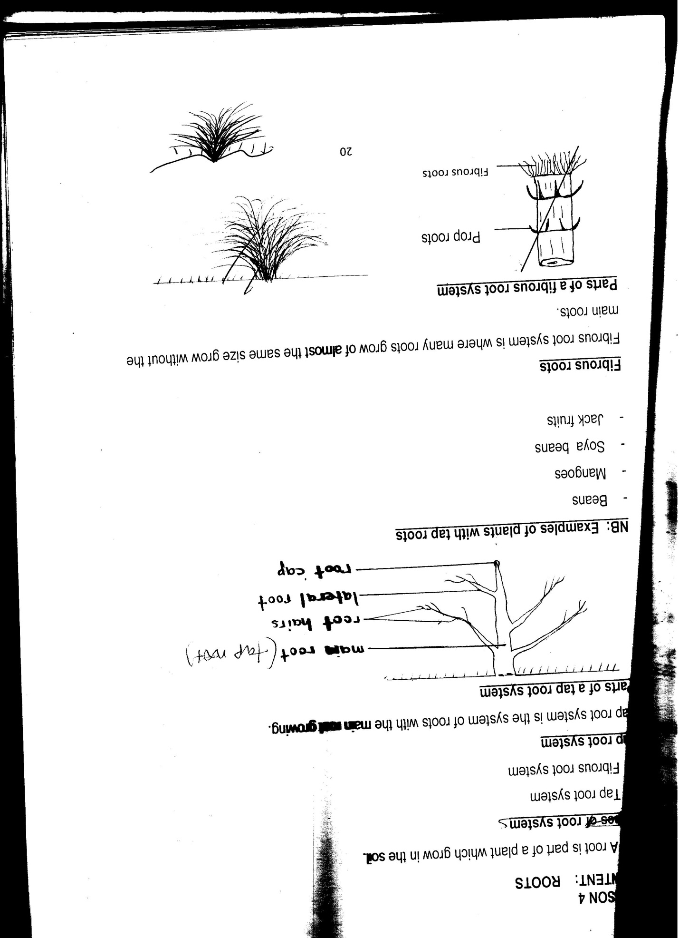**Parts of a tap root system**

**NB: Examples of plants with tap roots**

* Beans
* Mangoes
* Soya beans
* Jack fruits

**Fibrous roots**

Fibrous root system is where many roots grow of almost the same size grow without the main roots.

**Parts of a fibrous root system**

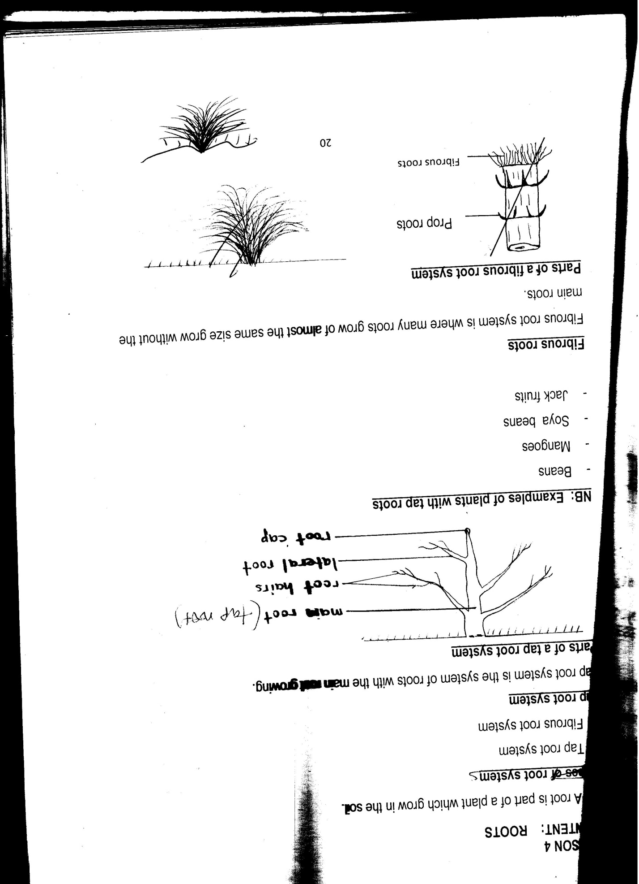

**Examples of plants with fibrous roots**

* maize
* sorghum
* sugar cane
* millet
* rice

**Exercise**

**LESSON 2**

**CONTENT: Uses of roots to plants**

* Roots hold plants firmly in the soil.
* Roots absorb water and mineral salts from the soil.
* Some roots store food for plants e.g. cassava, sweet potatoes, carrots.

**Uses of roots to people**

* Some roots are eaten as food e.g. cassava, sweet potatoes, carrots.
* Some roots are used as local medicine
* Some roots are used as firewood.

**Examples of plants whose roots are eaten /root tubers**

* Cassava plants
* Sweet potatoes plants
* Carrot plants
* Root turnips

**Exercise**

**LESSON 2**

**CONTENT: FLOWERS**

A flower is a reproductive part of a plant

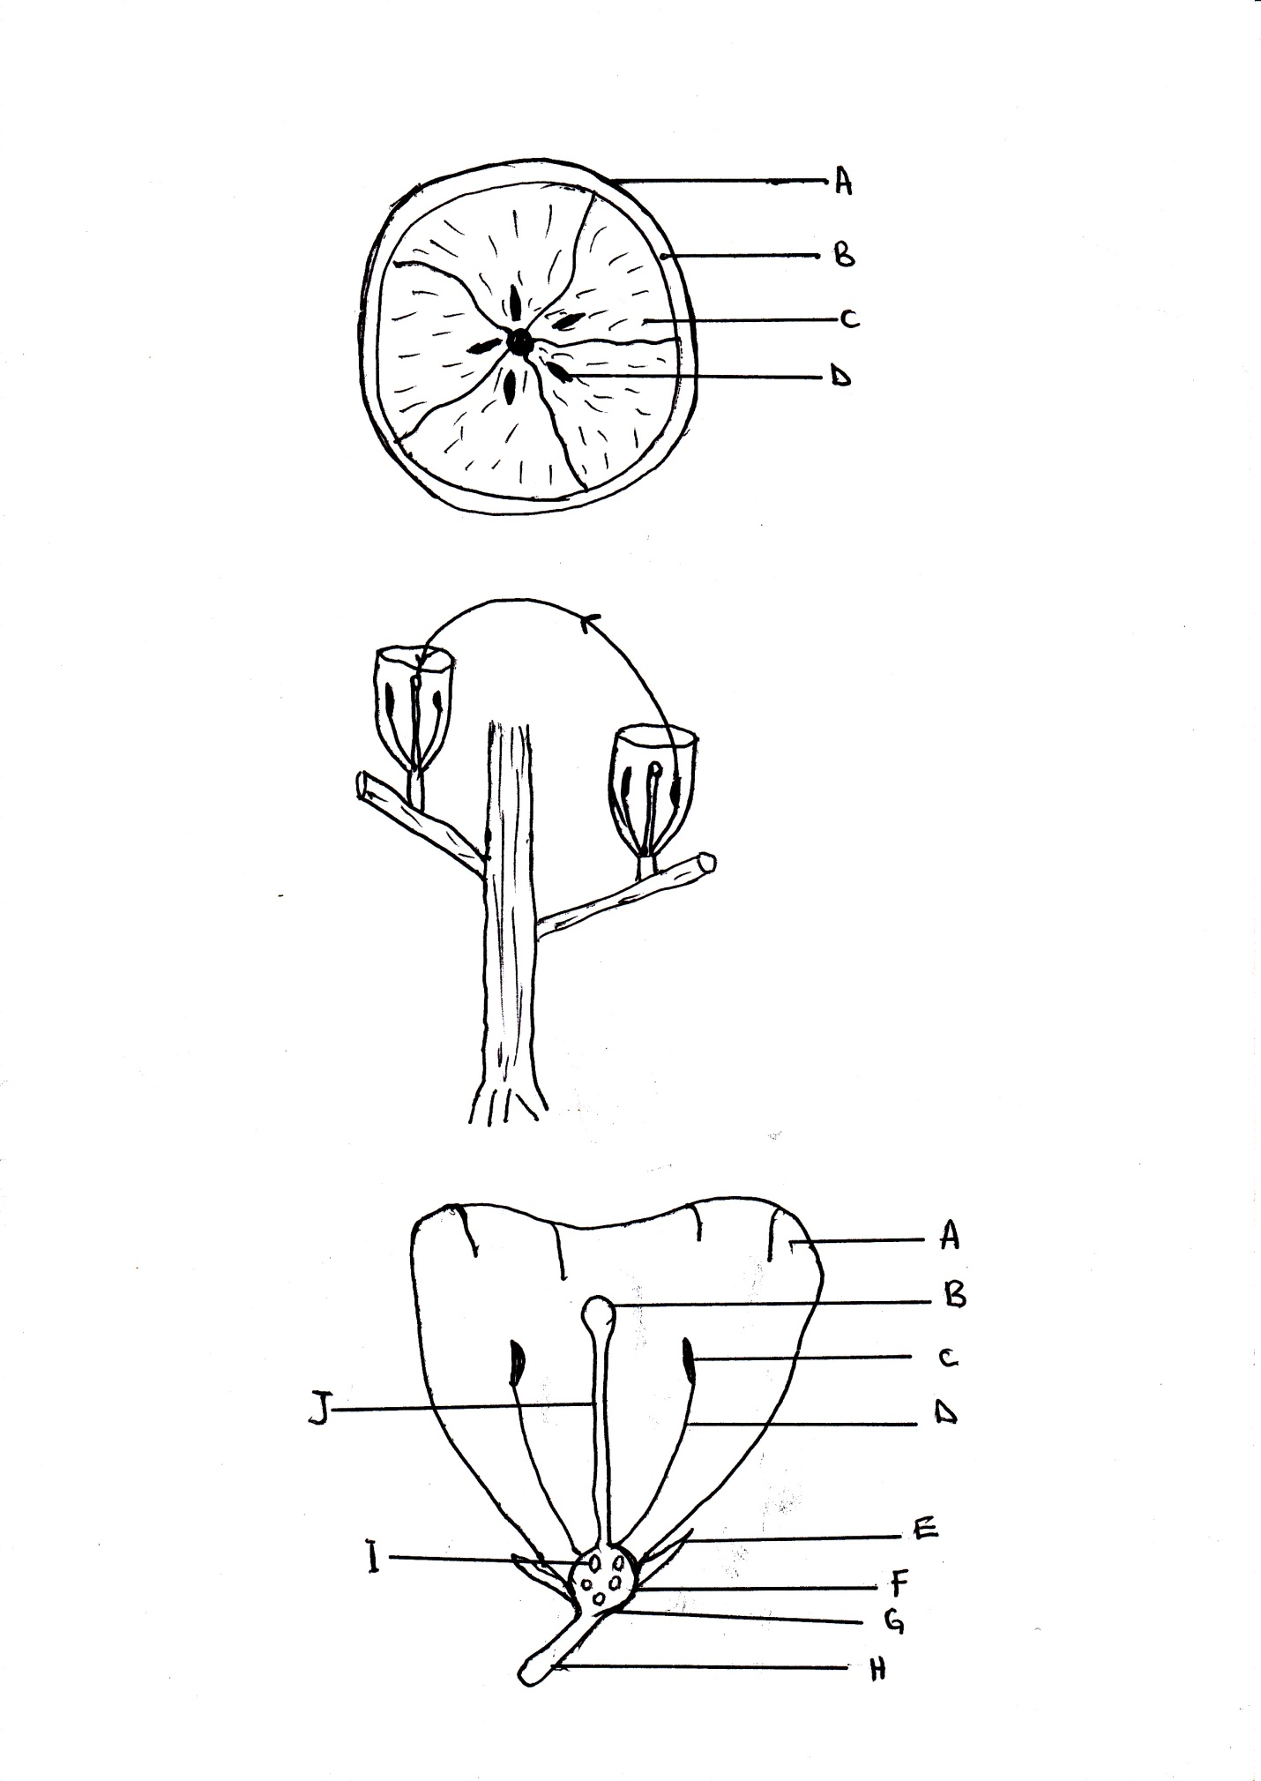**Parts of a flower**

Petals

Stigma

Anther head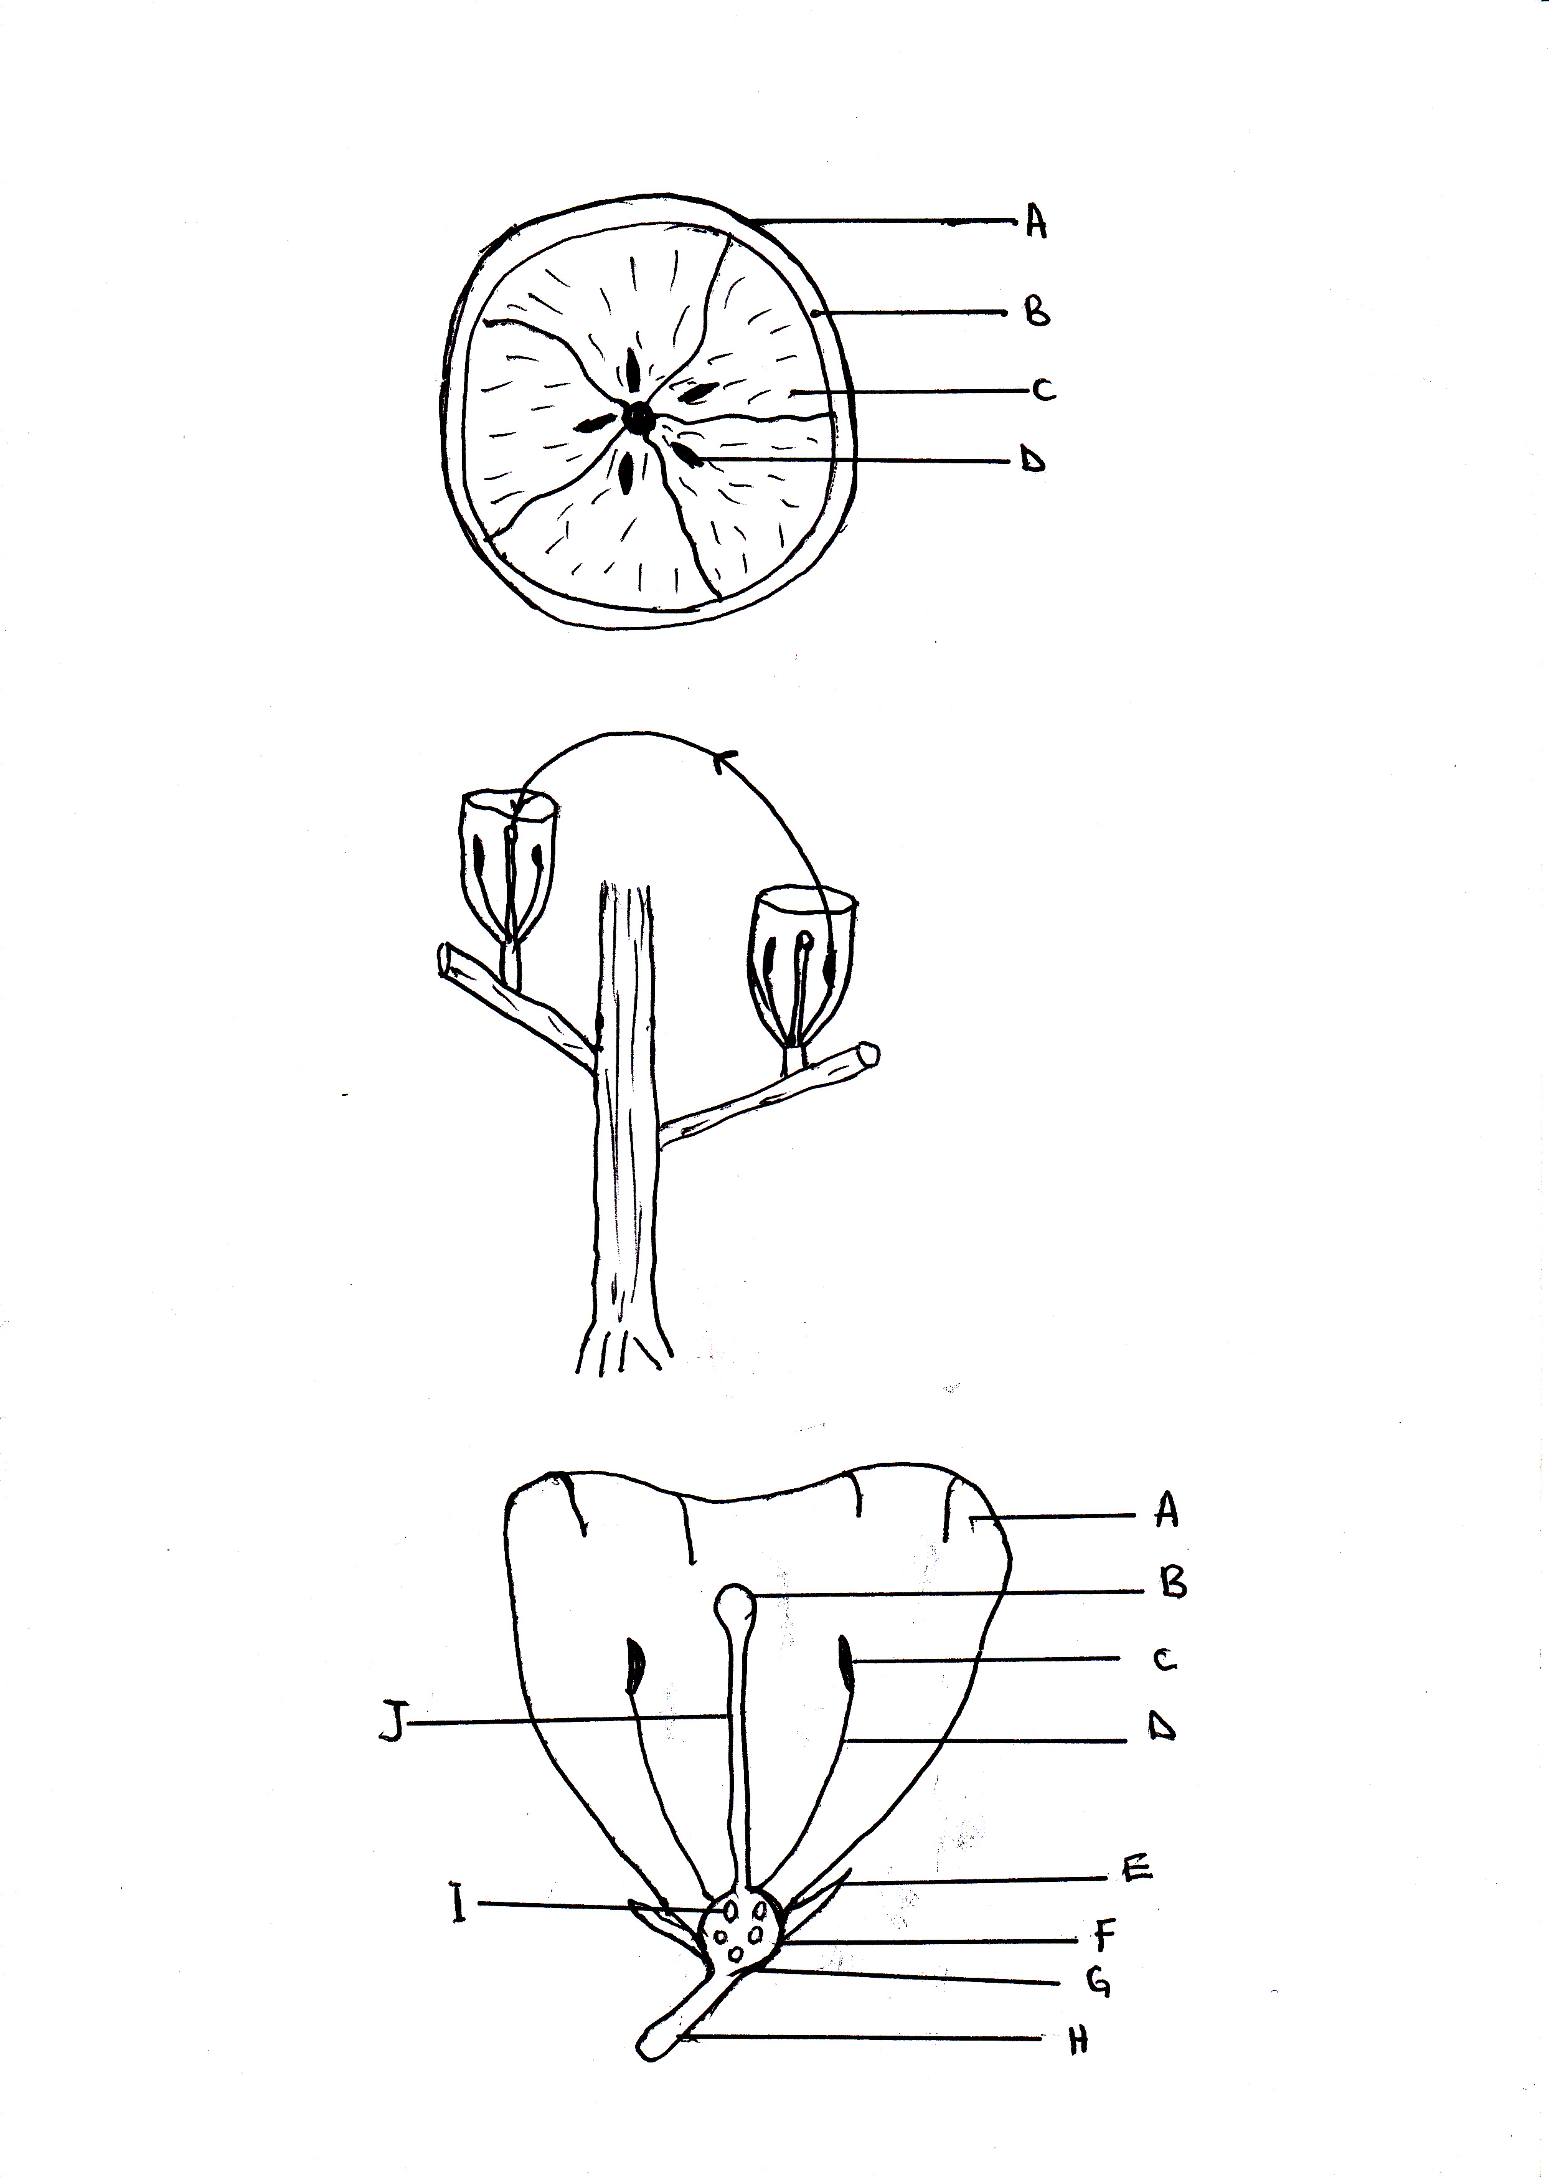

Style

filament

Ovules

Sepal

Receptacles

ovary

Flower stalk

Note: A group of petals is called corolla

* A group of sepals is called calyx
* A female part of a flower is called pistil
* A male part of a flower is called a stamen

**Parts of a pistil parts of a stamen**

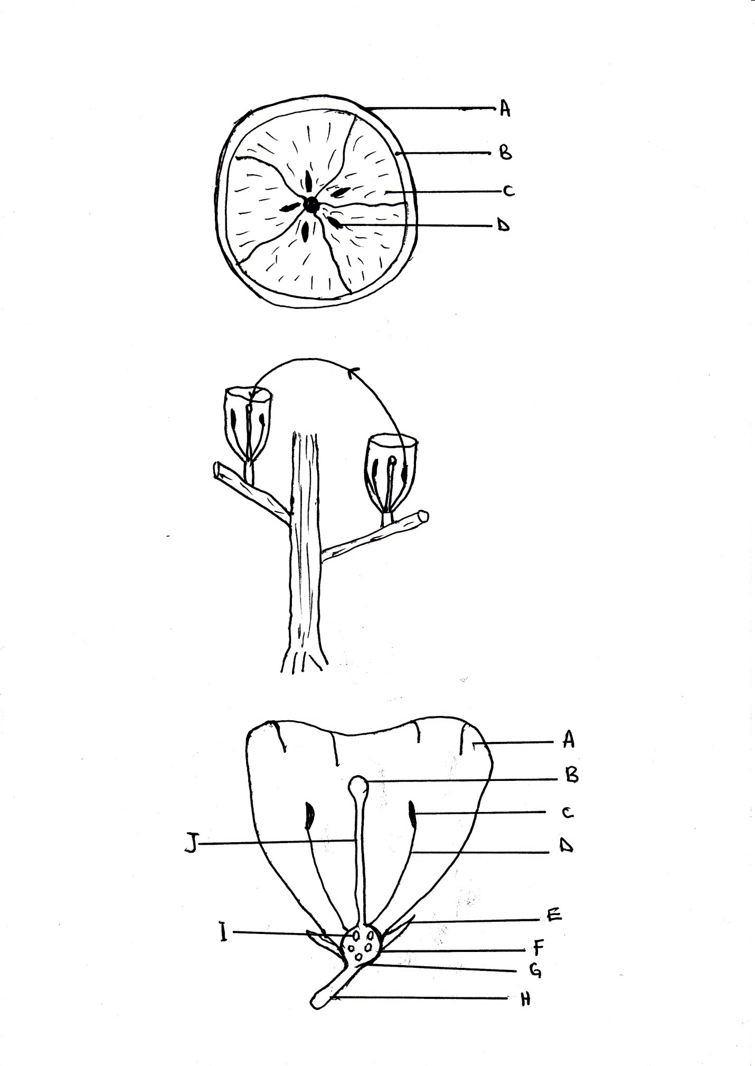

anther head

Stigma

Filament

Style

Ovary

**Exercise**

**LESSON 3**

**CONTENT: Uses of parts of a flower**

* Petals – protects the inner parts of a flower
* Sepals – to protect the flower when it is still in a bud stage.
* Ovules – develop into seeds after fertilization
* Ovary – protects ovules
* Anther – to produce and store pollen grains
* Stigma – receives pollen grains
* Style – Holds the stigma upright
* Filament – holds anthers in position
* Flower stalk – holds a flower in a right position

**NB: Why insects visit flowers**

* To get nectar (main reason)
* To get pollen
* To get water

**Insects that visit flowers**

* Bees
* Butterfly
* moth (at night)

**Exercise**

1. How useful are the following parts to a flower?

Ovary _____________

Anther ______________

Stigma _____________

1. State one use of flowers to people.
2. Why should we wash hands with soap after visiting latrines?
3. Why do bees visit flowers?

**LESSON 4**

**CONTENT: Uses of flowers to people**

* Flowers are given as gifts
* Flowers are given to people to show respect and welcome
* Flowers are used for decoration
* Some flowers are eaten as food e.g. cauliflower, pumpkin flowers.
* Some flowers are used for making perfumes
* Flowers are sold to get money

**Uses of flowers to plants**

* Flowers are used for reproduction

**Uses of flowers to people**

* For decoration
* They are used for social functions as gifts.
* They are sold for money.
* Some flowers are eaten as food. Pumpkin, spider sunflower.

**Mixed activity**

1. How useful are flowers to people?
2. List any two functions where flowers are used for decorations.

**LESSON 1**

**CONTENT: CROP GROWING PRACTICES**

* Clearing land
* Planting
* Weeding
* Mulching
* Thinning
* Pruning

**Clearing land**

Through

* Slashing using a slasher
* Ploughing using oxen
* Gathering using a rake, hoe and pick axe
* Digging up soil
* Leveling the soil
* Burning of the rubbish/ bush

**Planting**

It involves selecting seeds and transplanting.

**Transplanting** is the transfer of seedlings from the nursery bed to the well prepared garden.

**Methods of planting crops**

1. Row planting - ( planting in lines)
2. Broadcasting – (scattering seeds using hands) e.g millet, sorghum

**Caring for crops**

* Weeding
* Pruning
* Thinning
* Mulching
* Stalking
* Watering
* Spraying with chemicals

**Exercise**

1. How can a farmer care for his maize in the garden?
2. Mention one activity carried out during land preparation
3. What is a nursery bed?
4. Mention at least two methods of planting crops.

**LESSON 2**

**CONTENT: Types of crops**

* Vegetable crops
* Cereal crops
* Legumes
* tuber crops
* Fruit crops

**Vegetable crops**

**e.g.** cabbages, pig weed, onions, lettuce, spinach

**Cereal crops**

These are crops which produce grains e.g. (grains are seeds which provide flour) e.g. millet, maize, sorghum, wheat, barley, rice

**Legumes**

These are crops whose roots have nodules e.g. beans, ground nuts, soya beans, green peas, cow peas, Bambara nuts.

**Fruit crops**

These are crops that provide fruits e.g. oranges, pineapples, passion fruits, mangoes

**Tuber crops**

These are crops that store food in their underground parts e.g. cassava, sweet potatoes, white yams carrots and inch.

**Tuber crops**

1. Stem tubers e.g irish potatoes, white yams
2. Root tubers eg cassava, sweet potatoes, carrots

**Exercise**

**LESSON 3**

**CONTENT: Garden tools and their uses**

|  |  |  |
| --- | --- | --- |
| Name | Diagram | Use |
| Trowel |  | * For transplanting seedlings |
| Panga | C:\Users\user\Desktop\scan0004.jpg | * For cutting down small trees |
| Watering can |  | * For watering crops |
| Hoe |  | * For digging * For weeding |
| Spade |  | * Removing manure * Removing loose soil |
| Slasher | C:\Users\AA\Pictures\2017-05-29 SCIENCE 003\SCIENCE 003 001.jpg | * For slashing * For cleaning land before digging |
| Axe | C:\Users\user\Desktop\scan0004.jpg | * Cutting big trees |
| Knapsack sprayer | C:\Users\AA\Pictures\2017-05-29 SCIENCE 2\SCIENCE 2 001.jpg | * For spraying |
| Secateur | C:\Users\AA\Pictures\2017-05-29 SCIENCE 2\SCIENCE 2 001.jpg | * For pruning |

**LESSON 4**

**CONTENT: Caring for garden tools**

* Keep garden tools in a cool dry place.
* Cleaning garden tools after using
* Sharpen garden tools used for cutting
* Paint metallic tools to avoid rusting

**Reasons for caring for garden tools**

* To prevent metallic tools from rusting
* To keep tools for a long time.

**Prevention of garden tools from rusting**

* By oiling
* By painting
* By keeping metals in a clean dry place
* By cleaning and drying them after use

**Exercise**

**LESSON 1**

**CONTENT: GERMINATION**

Is the development of a seed into a seedling.

* A seedling is a young plant

**Conditions needed for germination**

* Oxygen
* Moisture / water
* Optimum temperature

**Uses of each condition**

Oxygen : for respiration

Water: dissolves food for the embryo.

Moisture: makes the testa a soft

**Exercise**

1. How do we call the development of a seed into a seedling?
2. Why is oxygen needed for germination to take place?

**LESSON 2**

**CONTENT: CROP PESTS**

Crop pests are organisms which destroy crops

**Examples of crop pests**

* rats
* locusts
* caterpillars
* crickets
* monkeys
* termites
* weaver birds
* been weevils
* moles
* squirrels
* birds

**Dangers of crop pests**

* Pests destroy crops
* Pests lead to low yields
* They eat up plant leaves
* Destroying of fruits

**How to control pests and diseases**

* Spraying with pesticides
* By weeding
* Trapping pests
* Using scare crows
* Cats can be used to control pests like rats in granary
* Uproot and burn infected crops
* Practice crop rotation
* by chasing the pests

**Signs of pest damage on crop**

* Holes on leaves
* Yellowish leaves
* Holes in fruits
* Wilting of crops, drying of the crops

**Exercise**

**Living things (plants)**

**Word bank**

bear

spores

stomata

oloevera

photosynthesis

carbon dioxide

chlorophyll

corolla

calyx

pistil

stamen

fertilization

pollen grains

staking

cerals

legumes

rusting

optimum

pesticides

moisture